**NEWS PHONE APPLICATION**

Detailed Design

COP 4331 Section 1

Fall 2010

**GROUP 8**

Karl Banks

Aaron Birencwaig

Andrew Harmic

Jason Heintz

Stephen Rodriguez

Tyler Zaino

UNIVERSITY OF CENTRAL FLORIDA

**DETAILED DESIGN**

|  |  |  |  |
| --- | --- | --- | --- |
| Modification history: | | | |
| **Version** | **Date** | **Who** | **Comment** | |
| v1.0 | 10/17/10 | Jason Heintz | Initial class diagram | |
| v1.1 | 10/20/10 | Aaron Birencwaig | Modified class diagram | |
| v2.0 | 10/23/10 | Tyler Zaino | Added detailed design issues | |
| v3.0 | 10/24/10 | Stephen Rodriguez | Added trace of requirements to design | |

1 Design Issues

1.1 Reusability

The program will be written with reusability in mind. This is a very beneficial practice for many reasons. The main reason is the availability to reuse the code for each section of news. This way we are able to maintain consistency in both the presentation and the content of each subsection of news. The practice of reusability also helps in the debugging phase. Since each subsection of news will be written with the same code, a bug found in one section will be easy to spot and fix in all of the other sections as well.

1.2 Maintainability

The way the application will be written makes maintainability a very easy task. Essentially, the program will scan through each section of the CNN website, and collect the news stories for the application. Once the new stories are found, the text is parsed and reprinted as an article on the application. The pictures associated with each article are also collected the same way. Unless CNN does a drastic overhaul of its website, the method that will be used by the application provides very little reason for the programmers to have to maintain it on a regular basis.

1.3 Testability

Due to the vast amount of reusability that will be built into the code, the testing of the application becomes much simpler. As stated previously, many of the bugs will likely be repeated throughout the application since the foundation of the code for each subsection will be the same. Also, the amount of different test cases will be at a minimum. This is a benefit because it allows the testing of each case to be very thorough and in depth to ensure each feature is working properly under all types of test conditions.

1.4 Performance

The code will be primarily written with performance in mind. For the application to be useful, it must run at peak performance for the majority of the time, because no one wants old news. This performance will be achieved by allowing the application to quickly retrieve the stories from the CNN website. This eliminates the need to store the articles in a database. This method cuts down the amount of overhead it would cost to consistently access the database, which at peak times could be flooded with users, slowing down the retrieval of the news articles.

1.5 Portability

The portability of the application is also a main concern during the development of the design. The essential purpose of a mobile application is for it to be a scaled-down version of the actual website, providing only the essentials to the user’s phone. By design, the application will be written with well organized subsections that allow the user to quickly access the top news stories they desire. If the user wants to continue to look for new articles, an option is available to view more. This allows for the application to be compact and efficient. Also, the code will be written to allow any Android device to use the application. This will be done to ensure the majority of the Android users have the availability to use our application.

1.6 Safety/Security

To eliminate much of the need to add security features, the mobile application won’t be programmed to hold any of the user’s personal or confidential information. Also, since the news stories will be taken directly from the CNN website in a text format, there is very little risk of infection by virus. The only safety measure that will be built into the code is the way the program parses the stories from the website. The text parser must be very dynamic to ensure no unwanted text will able to pass through to the application.

1.7 Prototyping

The program will be written with many subsections, allowing for the release of many prototypes. The initial prototype will be the basic interface the user will encounter each time the device is loaded up. Then after each section is individually created, a new prototype will be released with that function now enabled. This will allow for testing to begin quickly. Also, releasing the application in pieces will allow for regression testing, this is used to ensure that each new release does not affect the functionality of the previous releases.

1.8 Technical Risks

To yield better performance, there is always a sacrifice. In this application, the benefit outweighs the single risk. Due to the nature of the program, the application will rely heavily on the CNN website to gather its stories. Since a database is going to be eliminated from the design to boost performance, if the CNN website goes down, the news stories will be unavailable until their site is back up and running. Though this may be seen as a critical risk, it will also ensure that all of the news stories being provided by the application are up-to-date.

2 Detailed Design Information

2.1 Class Diagram

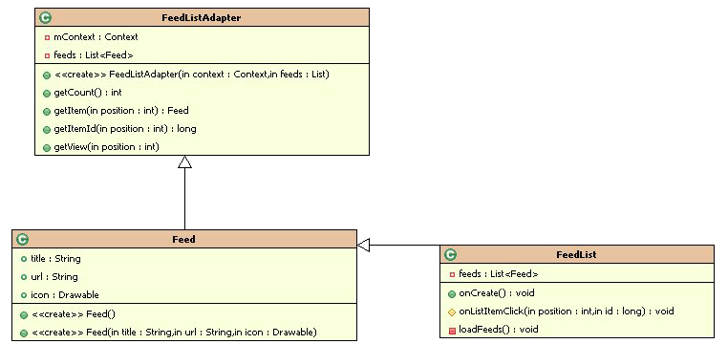

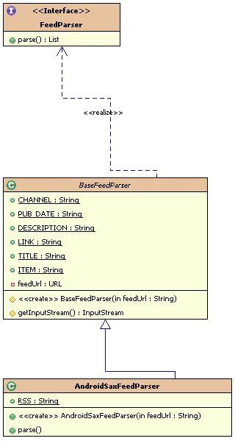 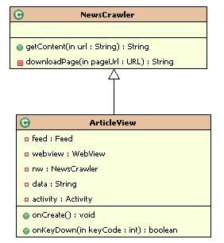

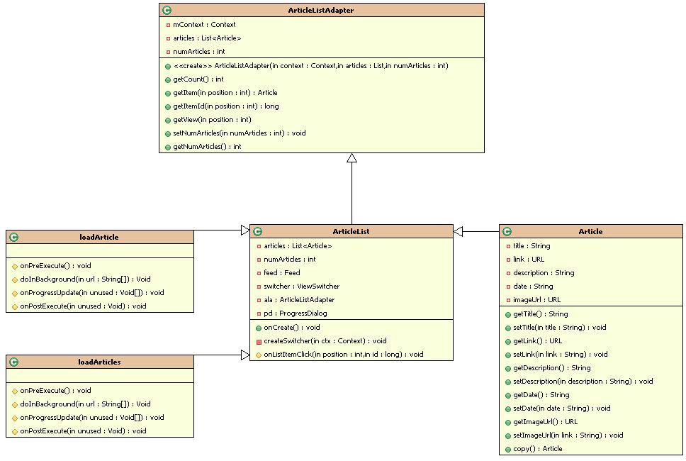

3 Trace of Requirements to Design

|  |
| --- |
| **No: 001** |
| Statement: The News Phone Application shall display content on the following five areas: US, World, Money, Entertainment, and Sports |
| This is handled in multiple areas. First these sections are displayed by the drawable class for the user interface. Then the feed class gets the articles based on the type of the content. |
| **No: 002** |
| Statement: The News Phone Application shall depict a single important headline news item at its home screen. |
| This will be handled in the Article class by the getImage function. |
| **No: 003** |
| Statement: The News Phone Application shall have a drop down available that lists all news sections covered. |
| This will be handled by the drawable class that will provide the interface with all the subsections listed. |
| **No: 004** |
| Statement: The News Phone Application shall display, at the minimum, five news items per news section covered. |
| This will be handled in the ArticleListAdapter class by the setNumArticles and getNumArticles functions. |
| **No: 005** |
| Statement: The News Phone Application shall give the user the ability to show more news articles for each news section covered. |
| This will be handled in the ArticleListAdapter class by the setNumArticles and getNumArticles functions by changing the increasing the number of articles. |
| **No: 006** |
| Statement: The News Phone Application shall display an error message whenever the application fails to connect to the internet. |
| This will be handled in the ConnectivityManager class by the extra_no_connectivity function. |
| **No: 007** |
| Statement: The News Phone Application shall display content for every link within five seconds upon execution of that link. |
| This will be handled in the articleList class and the performance will stem from the fact the articles are coming directly from the CNN feed. |